EXPERIMENT 5
DDL COMMANDS (COLLEGE SCHEMA)

Aim:
- Create a schema called College.
- Create tables for students (attributes: student id, name, gender, subject, marks and grade), faculty (attributes: faculty id, name, course and pass percentage), department (attributes: department id, name, section, strength and pass percentage) and activity (attributes: activity id, name, strength and category)
- Add and modify:
  - Address in students table, change datatype size of student name and make student id primary key
  - Add faculty total mentor details, make faculty id as primary key
  - Add number of students in wise in department table and make department id as primary key
  - Add faculty name to activity table, change the datatype size of activity name and make activity id as primary key

1. Create schema college
2. Create table-student and attributes are studid, studname, gender, subject, marks, grade.
3. Create table-faculty and attributes are fac_id, fac_name, course, pass percentage.
4. Create table-department and attributes are dept_no, dept_name, section, no of students, pass percentage.
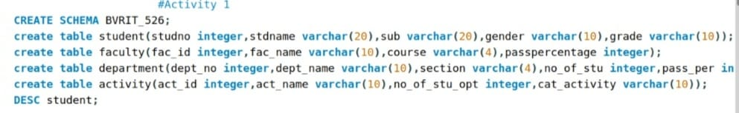
5. Create table-activity and attributes are act_id, act_name, no of students opted, category of activity.
TABLE:

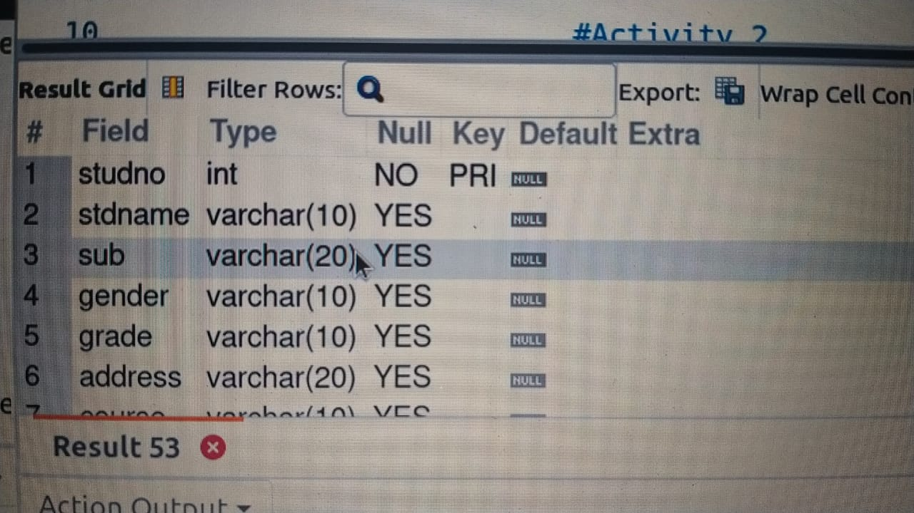

1.Add address in student table ,change the datatype size for student name and make studid as primary key.
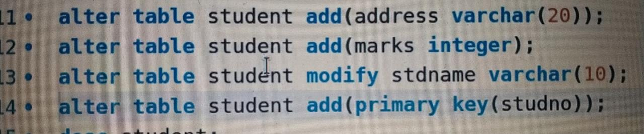
2.Add faculty total mentor details ,make4 fac_id as primary key.
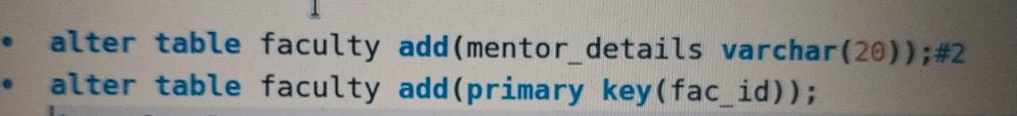

3.Add no of students in wise and make dept no as primary key.

4.Add faculty name and change the size of act_name and act_id as primary key.
